1. 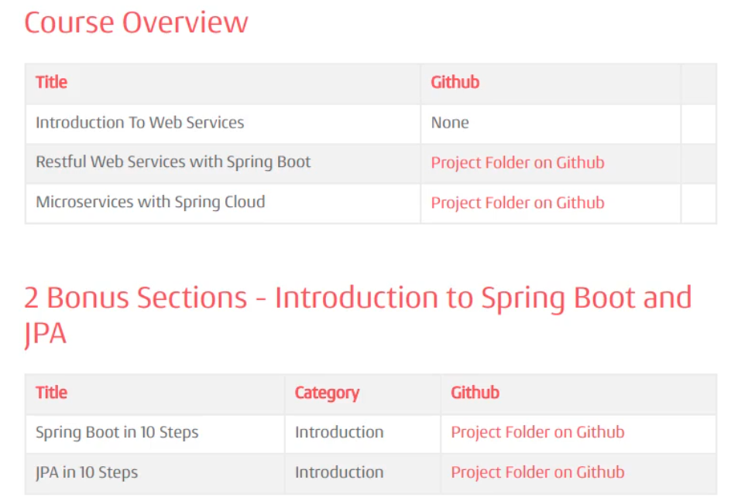
2. See the Doc file in the folder.